September 19, 2026
Yash Rastogi

Solutions
AccuKnox AI/ML trainee-Problem Solving
Problem statement- assignment 2
- Where would you rate yourself on (LLM, Deep Learning, AI, ML). A, B, C [A = can code independently; B = can code under supervision; C = have little or no understanding]
- What are the key architectural components to create a chatbot based on LLM? Please explain the approach on a high-level
- Please explain vector databases. If you were to select a vector database for a hypothetical problem (you may def
My Answers:
- I would rate myself as
LLM: A = can code independently
Deep Learning: B= can code under supervision
AI: B= can code under supervision
ML: B= can code under supervision
I have made 2-3 projects, One under supervision in my ongoing internship at SCAII and rest are self-made.

An LLM chatbot is an assistant powered by a large language model designed to generate or guide responses based on a user’s input.

The architecture components required to create a chatbot based on an LLM are:

- User Interface (UI): An LLM chatbot is an assistant powered by a large language model designed to generate or guide responses based on a user’s input
- The Orchestration Layer: Its basically the backend of the chatbot, it manages user requests , calls external API’s and manages data using framework’s like LangChain
- Core of the LLM: The generative model that turns text into tokens and generates human like responses in the output.
- Memory System: Using RAG and vector databases to store documents , this helps prevent hallucinations and improves accuracy.
- Safety layer: This layer filters and set rules that block harmful or inaccurate answers.

In my own RAG-based system (HyRAG), the orchestration layer combined semantic search and BM25 keyword search before passing retrieved context into the LLM core, with the prompt explicitly instructing the model to cite sources an example of how the memory/knowledge system and safety layer can work together to reduce hallucination
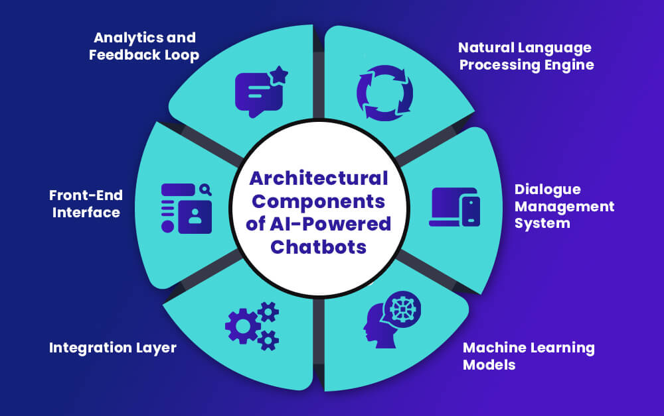
Basic structure of the architecture components of a chatbot

3.
A vector database is a type of database that is designed to store, manage, and index massive quantities of high-dimensional vector data efficiently. In traditional relational databases, data points are represented with rows and columns. In vector database, vectors represent data points with a fixed number of dimensions, clustered based on similarity.
Sample problem:
I have a small organization where I wanted all the important documents to be stored.
Suppose, there is a new joiner, that doesn’t know the companies policies or needs some information about a certain project. Normally , they ask someone who’s a higher authority and get the information verbally or via a company site , but about the project , the information there is only known by some people and it may be confidential. So, in this case we can use a vector database along with RAG that has knowledge about the project , it also has the knowledge about the company.
Solution:
For the above scenario , I would use ChromaDB, Its an open source vector database that is made for storing , managing and querying embeddings. Normal or standard DBs are just used to look up the exact text but they will struggle with contextual data. ChromaDB uses Semantic similarity which means that it looks for the info based on the context. I preferred this because , its developer friendly and also has reduced cost since its open source. It can be used in small selfhosted container while using existing embeddings like (gemni or OpenAI) . The only disadvantage is that it isn’t enterprise level, that is if compliance is required and more scalability is required then ChromaDB isn’t the best. The alternative is Pinecone , it offers better scalability and compliance but comes at a higher cost.

